* ***Layout:*** WHITE BOARD

CHAIR

**D 1 TABLE D**

**M 1 M 15**

W 1 W 6

**M 2 M 14**

**M 3 M 13**

W 2 W 5

**M 4 M 12**

W 4

**M 5 M 11**

W 3

**M 6**

**M7****M8****M9****M 10**

***Machines in Thermodynamics Lab***

* **Two Stroke Petrol Engine :**

They allow asymmetric intake of the fuel charge improwing power and echonomy widewidning the power band.They widely used in Motor cycle ATV and outboard engine.

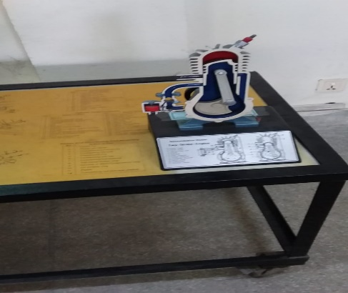

* **Four Stroke Diesel Engine:**

Four Stroke Engine is an internal combustion engine in which the piston complete four separates strokes which constitute single thermodynamics cycle .

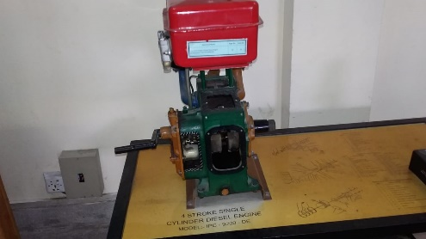

* **Rankine Cycle Turbine:**

Rankine Cycle is a model used to predict the performance of steam turbine systems reciprocating steam and convert heat into the mechanical work when phase change

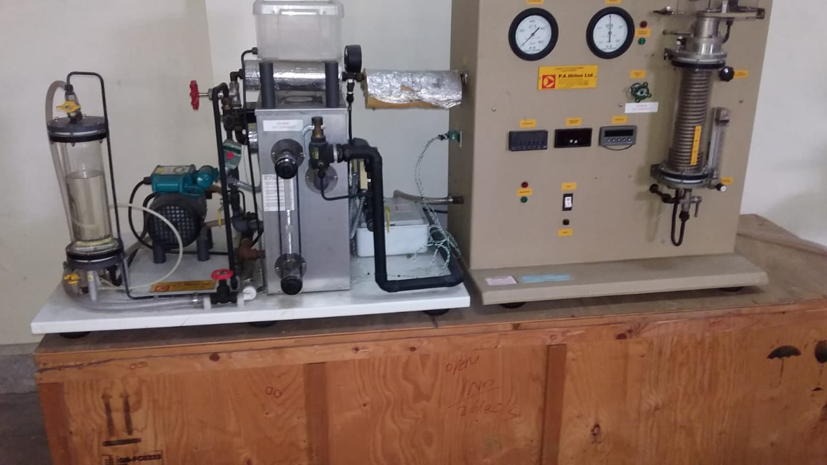

* **Nozzle Distribution Pressure And Compressible Flow Range:**

It is used for in the subsonic range.Velocities in the supersonic range can be achieved in de level nozzle.

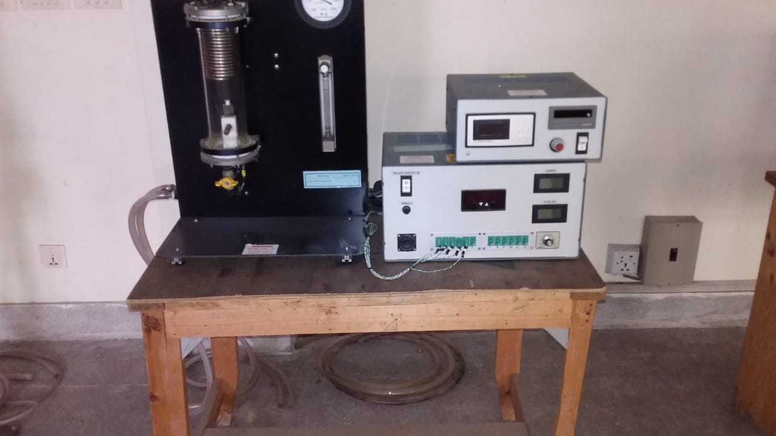

* **Heat Transfer Unit:**

It is used in calculating the heat transfer, typically by convection or phase transition between fluid and a solid.

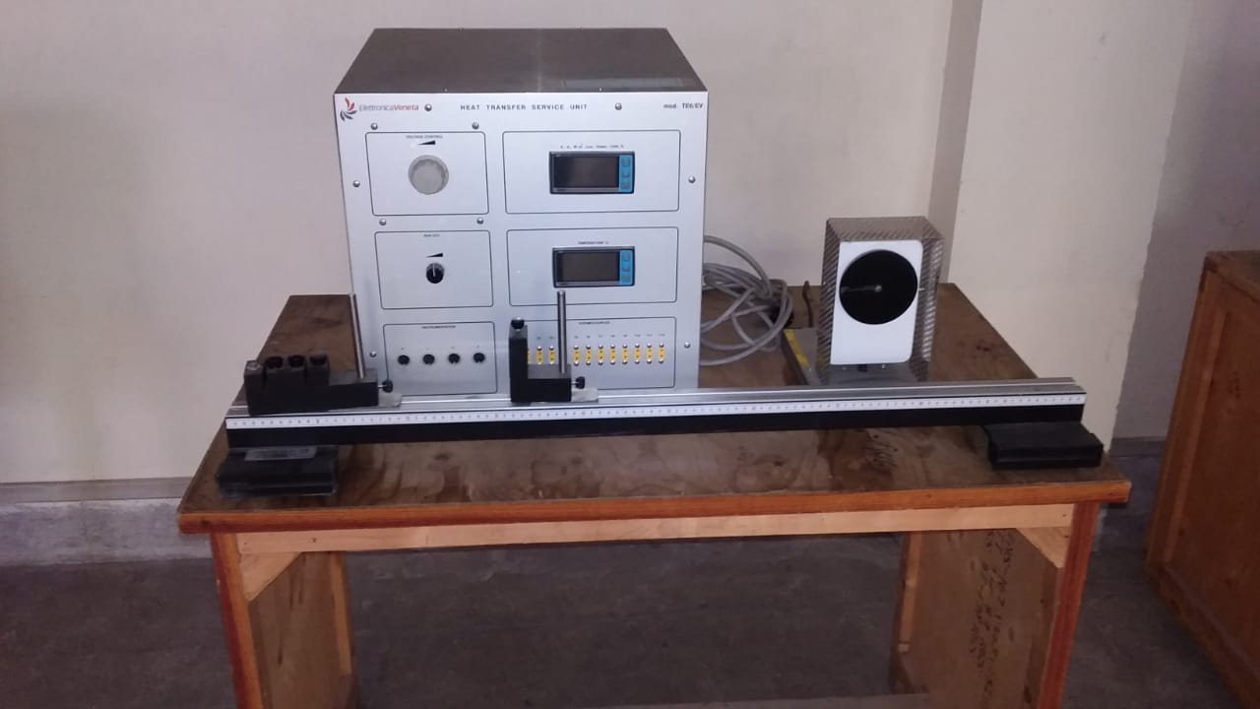

* **Commercial Refrigerator Trainer:**

The trainer is acompletely self contained and operational unit that contains the basic component found in many refrigerator and AC.

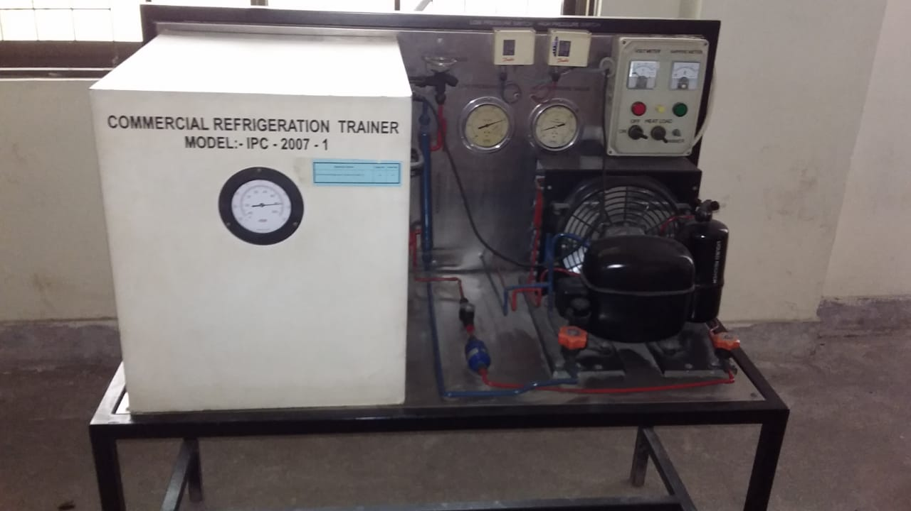

* **Mechanical Heat Pump Trainer:**

Mechanical heat pump is the most prevailing heat pump to be applied commercially.The pressure of refrigent is increased with the use of a compressor.

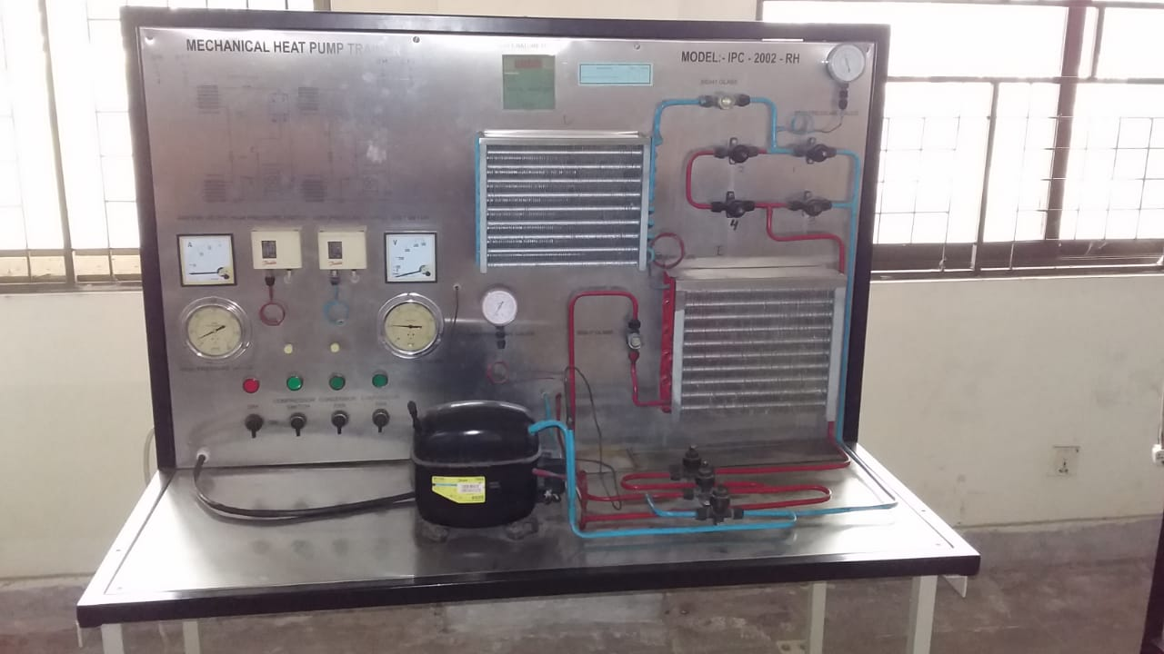

* **Flow Boiling Demonstration:**

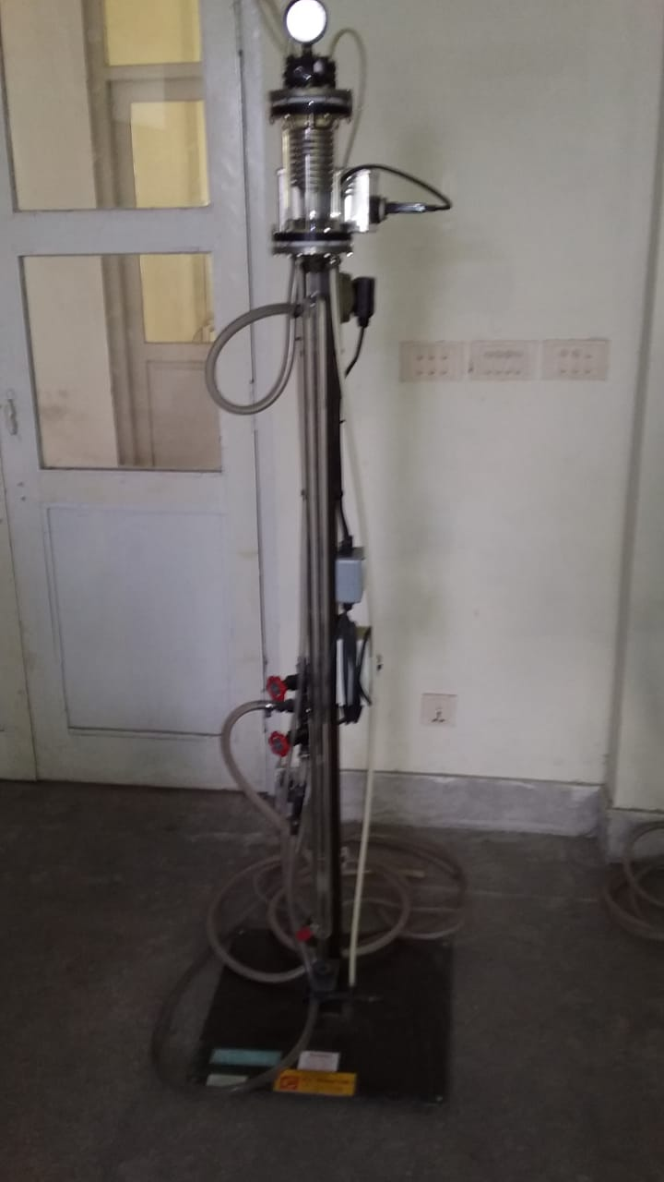

***THE END***